**m rumman hasan 60661**

Assignment #1

**FLOATING STATIC ROUTE**

**Definition:**

Static routes have a very low administrative distance of 1, this means that your router will prefer a static route over any routes that were learned through a dynamic routing protocol. If we want to use a static route as a backup route, we’ll have to change its administrative distance. This is called a **floating static route**.

**Topology:**

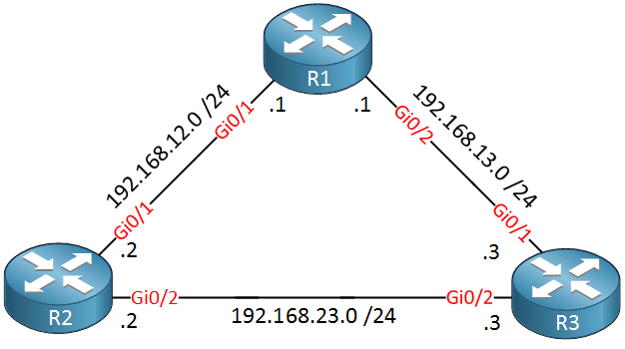

**Commands:**

R1(config)#router rip  
R1(config-router)#version 2  
R1(config-router)#no auto-summary   
R1(config-router)#network 192.168.12.0

R2(config-router)#version 2  
R2(config-router)#no auto-summary   
R2(config-router)#network 192.168.12.0  
R2(config-router)#network 192.168.23.0

R1 should now be able to reach this network through R2:

R1#show ip route | begin 192.168.23.0

**LOAD SHARING**

**Definition:**

Load sharing is inherent to the forwarding process of a router to **share** the forwarding of traffic, if the routing table has multiple paths to a destination. If equal paths, the forwarding process will decide the manner of forwarding and forward packets based on the load-sharing algorithm used.

**Topology:**

n/a

**Commands:**

n/a

**Recursive Route**

**Definition:**

A recursive static route is a route whose next hop and the destination network are covered by another learned route in the Routing Information Base (RIB). Such static routes cannot be installed in the RIB because they are considered redundant routes

**Topology**

n/a

**Commands**

**SUMMARY STEPS**

**1. enable**

**2. configure terminal**

**3. vrf definition vrf-name**

**4. rd route-distinguisher**

**5. address-family {ipv4 | ipv6}**

**6. exit**

**7. exit**

**8. ip route [vrf vrf-name] prefix mask ip-address**

**9. ip route static install-routes-recurse-via-nexthop [vrf vrf-name]**

**10. end**

**11. show running-config | include install**

**12. show ip route vrf vrf-name**

**Passive Interface**

**Definition**

Passive-interface command is used in all routing protocols to disable sending updates out from a specific interface. However the command behavior varies from one protocol to another.

**Topology**

## The passive interface Command

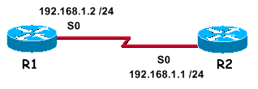

With EIGRP running on a network, the **passive-interface** command stops both outgoing and incoming routing updates, since the effect of the command causes the router to stop sending and receiving hello packets over an interface.

**Commands**

**Split Horizon**

**Definition**

The split Horizon technique transmits the data packets in forward direction and propagates to all the attached nodes, except that router which sent the new update. This technique prevents routing loops and also sublimates those areas, where Route Poisoning cannot avoid routing loops to occur.

The following simple example disables split horizon on a serial link. The serial link is connected to an X.25 network:

interface serial 0  
encapsulation x25  
**no ip split-horizon**